

MLib Yield Curves in a Nutshell

Version | Date | Author
1.0  2.0 | 01 Dec 2016  20 Sep 2017 | Joseph Ye  Nicholas Burgess

Contents
Disclaimer 4
Yield Curves in MLib 5
OIS Curve 7
Short end 7
Central Bank Swaps 8
Long End 10
Swap (STD) Curve 12
Spot Interest Rate Deposits 12
FRAs 12
Futures 13
Tension in FRAs/Futures 13
Vanilla Interest Rate Swaps 14
Tenor Basis Swaps 15
Tenor/Xccy Basis Curve 17
Spot Libor Instrument 17
FX Forwards 17
Tenor Basis Swaps 18
Xccy Basis Swaps 20
Xccy Swaps 21
FX Forward Constant Curve 22
Appendix 1: Yield Curve State Variables 22
Appendix 2: Yield Curve Key Parameter Settings 23
2A: OIS Curve Settings 23
2B: STD Swap Curve Settings 24
2C: Tenor- & Xccy Basis Curve Settings 25
2D: FX Forward Curve Settings 27

Disclaimer
This document serves as a true description of logics and analytics employed by MLib on building interest rate yield curves at the time of writing. Methods and analytics employed by MLib as described in this document may not be the most advanced in the industry and are under constant development. Any future developments in MLib on yield curve building will be documented in this article.

Yield Curves in MLib
Building yield curves in MLib consists of selecting instruments liquid enough that will provide information such as zero coupon rates, discount factors, forward rates, etc. to evaluate less liquid or more complex instruments. Calibrating MLib’s yield curves consists of determining a zero rate/discount factor function $z(0,t)$ that fits the market, i.e. prices the NPV of all the curve instruments to zero, so that market prices are recovered when pricing yield curve instruments on the calibrated curves.
The underlying principle of yield curve fitting is that instruments (swaps, FRAs, futures, basis swaps, etc) are always quoted at par, so that the corresponding contract is fair for both parties without the need for any upfront payment. In the case of a standard fixed/floating interest rate swap this means the discounted value of the fixed leg is equal to the discounted value of the floating leg:
$${ PV}_{IRS}$$
$=R\sum_{i=0}^{n-1}{τ_{fix}\left(t_{i,}, t_{i+1}\right) DF\left(0, t_{i+1}\right)-\sum_{i=0}^{m-1}{L\left(t_{i,}, t_{i+1}\right) τ_{float}\left(t_{i,}, t_{i+1}\right) DF\left(0, t_{i+1}\right)}}$ (1)
$$=0$$
Here $L\left(t_{i,}, t_{i+1}\right)$ is Libor forward rate and $R$ is the swap par rate or more accurately the ‘market quote’ of this instrument. $R$ is obviously not always a rate. For example basis swaps are quoted as a spread to be added to one of the floating leg; futures are quoted as a price = 100 – R, etc.
Each calibration instrument in MLib must meet the requirement of $PV\left(R,z\right)=0$, where $z$ is a vector of zero rates from the calibrated yield curve and is used to estimate the future cash flows of this instrument, or to discount them. It’s trivial to calculate the PV of an instrument when given $z$. Our curve calibration process is all about solving the inverse problem of finding $z$ that recovers the quoted R.
We choose to determine the vector of zero rates on the dates that correspond to the maturity dates of all calibration instruments. Zero rates on any other intermediate dates will be results of interpolations.
In MLib, we calibrate yield curves in a sequential order with a dependency structure that is fixed for a particular currency. Sequential calibration is not the most advanced yield curve building scheme in the industry but the discussion of its drawbacks is not in the scope of this document.
The diagram below gives a glimpse into how sequential curve building works in MLib:
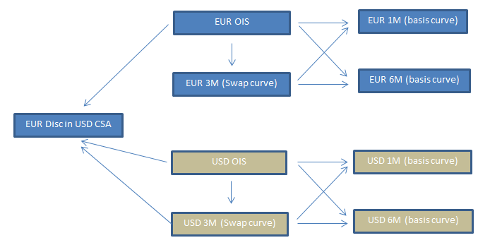

The example structure illustrated in this diagram can potentially become a lot more complex when non-USD CSA curves are involved. Regardless of the complexity, the curves are always built by having a sequential dependency on other curves. Currently there are four types of yield curves in MLib that serve as building blocks of any yield curve hierarchy:
- OIS curve
- Swap curve (STD)
- Tenor/Xccy Basis curve, and
- FX forward constant curve.
All these four types of yield curves are calibrated following the same principle outlined earlier. Technique-wise, combinations of the traditional bootstrapping technique and local solving schemes are employed throughout the curves in order to produce zero rates that allow the curve instruments to be priced back to par. Also, all of these curves support multiple interpolation schemes with the primary schemes being the Spline interpolation and Monotone Convex interpolation.

OIS Curve
It is critical to determine the forward curve of overnight rate for the pricing of collateralized swaps. Once an OIS curve has been created, the following two things can be achieved:
- Libor-based yield curves such as the 3M curve can be stripped relative to the OIS curve;
- When pricing collateralized swaps, cash flow discounting can be performed using the OIS curve;
The main building block of the OIS curve in MLib is Overnight Index Swap which exchanges fixed coupon and daily compounded overnight rate. When OIS swap of certain maturity tenors are not liquid enough, user can choose Libor swap quotes and the Libor-OIS basis spreads over outright OIS swap quotes.
The building of the OIS curve is faced with a number of challenges. As a result the curve is broken down into 3 sections each of which is built by a slightly different approach.

Short end
The short end of the OIS curve in MLib runs from the start of the curve (as-of date) up to either the 1Y tenor, or the beginning of the MPC (Monetary Policy Committee) swaps (or simply, central bank swaps).
This part of the curve only accepts outright OIS swaps:
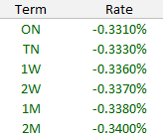
MLib uses short dated OIS rates to first determine the curve’s zero rates on short tenors. These zero rates are next used to aid in the determination of zero rates of the following longer tenors - a typical bootstrapping process.
Given the nature of short maturity tenor, all OIS swaps in this section are one-period compounding swaps with the quoted par rate being equal to the daily geometric compounded rate over the entire maturity tenor T:
$R=\frac{\prod_{i=0}^{n-1}{\left(1+f_{OIS}\left(i,i+1\right) τ\left(i, i+1\right)\right)-1}}{τ\left(0,T\right)}$ (2)
Or the daily arithmetic averaged rate:
$R=\frac{\sum_{i=0}^{n-1}{f_{OIS}\left(i,i+1\right)τ(i,i+1)}}{τ(0,T)}$ (3)
Where $R$ is the quoted OIS par rate, $f_{OIS}\left(i,i+1\right)$ is the daily overnight index rate, $τ(i,i+1)$ is the overnight date fraction taking into account of holidays and weekends, and $τ(0,T)$ is the date fraction of the instrument maturity.
Continuous compounding is used in formulating the discount factors which means in formulae (2) and (3) we have
$f_{OIS}\left(i, i+1\right)=\frac{\exp\left[z\left(0,i\right)τ\left(0,i\right)-z\left(0,i+1\right)τ\left(0,i+1\right)\right]-1}{τ\left(i, i+1\right)}$ (4)
In these three formulae there is one unknowns, $z$, which is precisely what we are seeking to find. The rest of the parameters are all known including the OIS swap par rates $R$ which are inputs to the yield curve building function.
Internally MLib uses an interpolator object to represent $z$. The purpose of building this part of the curve is to continuously tweak this interpolator object in solving routines so that it would eventually produce zero rates which according to the formulae above produce OIS swap par rates that are equal to the input quotes.
The solving process is based on the Newton Raphson scheme and is carried out on each of the calibration instruments one after another:
$x_{n = }x_{n-1}-{\left(J_{f}\left(x_{n}\right)\right)}^{-1}f(x_{n-1})$ (5)
Where $x$ represents the zero rate that corresponds to the maturity tenor of a given calibration instrument, $n$ is the number of solving iterations and $f$ is par rate function of the input OIS swaps.
One calibration instrument after another, the solving routine tweaks the zero rate of the OIS curve corresponding to each swap’s maturity tenor (pillar tenors) so that the curve will price back to the same price. Zero rates on dates other than the pillar dates are results of interpolation and produced by the zero rate interpolator object.
Note to MLib users:
When the short end of the OIS curve consists of short tenor OIS swaps that are followed by central bank swaps (described in next section), the flag ‘smoothshortend’ (which is part of the OIS convention inputs) must be set to TRUE.

Central Bank Swaps
A key property of the OIS rates is that they are relatively constant between central bank meeting dates, particularly when the rate is closely tied to a central bank policy rate. This is a direct consequence of the policy rate only being changed at meeting dates.
Such a property makes this part of the OIS curve exhibit a piecewise step shape. The OIS curve in MLib captures this property and achieves a step shape through the use of central bank swaps in orange:
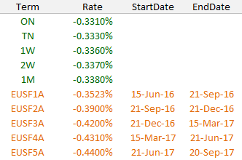
In essence, during the course of each central bank swap, daily discount factors are derived assuming constant overnight forward rate $f_{c }$ that is equal to the quoted swap rate:
$DF\left(0, T_{i+1}\right)= DF\left(0, T_{i}\right)* \frac{1}{1+ f_{c }τ(T_{i}, T_{i+1})}$ (6)
Daily zero rates are subsequently backed out from the daily discount factors:
$z\left(0, T_{i}\right)=\frac{-log⁡(DF\left(0, T_{i})\right)}{τ(0, T_{i})}$ (7)
MLib has addressed a couple of situations related to the transitioning from short end OIS swaps to the central bank swaps.
- If no short end OIS swaps are present in the OIS curve, the part of the curve starting from the spot date up to where the first central bank swap is, is assumed to have the same constant overnight forward rate as the first central bank swap rate;

- When a gap exists between the last short end OIS swap and the first central bank swap as illustrated below, daily overnight forward rates are linearly interpolated between the last short end swap and the first central bank swap;

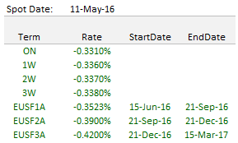

- When the last short end swap(s) overlap with the first central bank swap(s), as illustrated below, MLib user can control which group of instruments should take precedence over the other through flag ‘shorttermswapoverrules’ (part of the OIS convention inputs);

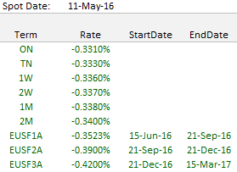
It’s important to note that all these different cases differ only in how the overnight forward rates should be determined. In all cases, formulae (6) and (7) are used to produce daily zero rates where central bank swaps are used.

Long End
The long end of the OIS curve in MLib consists of all the tenors that are longer than 1Y.
This part of the curve is modelled in a very similar way as the Short End:
- It follows the same one dimensional Newton Raphson solving routine on each of the calibration instruments;

- It uses the same interpolator object to produce zero rates;

- Zero rates are bootstrapped in the same fashion between calibration instruments;
However there are things very specific with the long end of the OIS curve that MLib has to deal with:
- OIS swap whose maturity tenor is longer than 1Y is no longer one-period compounding on its floating leg. The swap functions just like standard fixed-float vanilla swap, with both legs accruing on an annual basis and the fixed leg rate being the quoted OIS swap rate.

That means OIS swaps in this part of the curve should follow formula (1) to calculate its PV in the solving routines.

Also, the swap floating leg follows one of two ways to forecast the annual forward rate:

- A field called ‘CompoundingMethod’ is part of the MLib OIS Conventions inputs. When this field is left blank, forward rates are forecast just like Libor rates on an annual basis:

$f_{OIS}\left(i, i+1Y\right)=\frac{\exp\left[z\left(0,i\right) τ\left(0,i\right)-z\left(0,i+1Y\right) τ\left(0,i+1Y\right)\right]-1}{τ\left(i, i+1Y\right)}$ (8)

- When ‘CompoundingMethod’ is either ‘Arithmetic’ or ‘Geometric’, formulae (2) or (3) is used to calculate the equivalent rate over each one year period.

- Due to considerations such as liquidity, Libor swaps plus Libor-OIS spreads (which together form a structure of Libor-OIS basis swap) are often used in place of outright OIS swaps:

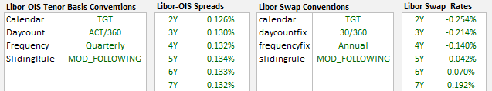

Libor-OIS swaps are activated in MLib by setting flag ‘longtermconvention’ to ‘LOBASIS’ and giving flag ‘longterm’ a starting tenor such as 3Y.

As always we aim to price the Libor-OIS basis swaps to PV 0 with the calibrated OIS curve. That means the following equations must hold:

${PV}_{Libor Leg}= \sum_{i=0}^{m-1}{f_{Libor}\left(t_{i,}, t_{i+1}\right) τ_{Libor}\left(t_{i,}, t_{i+1}\right) DF\left(0, t_{i+1}\right)}$ (9)
${PV}_{OIS Leg}= \sum_{i=0}^{n-1}{{(f}_{OIS}\left(t_{i,}, t_{i+1}\right) {+ R_{basis}) τ}_{OIS}\left(t_{i,}, t_{i+1}\right) DF\left(0, t_{i+1}\right)}$ (10)
${ PV}_{Libor Leg}= {PV}_{OIS Leg}$
Where $R_{basis}$ is the Libor-OIS spread given as input and $f_{OIS}\left(t_{i,}, t_{i+1}\right)$ is OIS forward rate according to formula (8).
Next, since we also know the Libor swap par rates, we have the following equations from a fixed-float Libor swap that also stand:
${PV}_{Libor Leg}= \sum_{i=0}^{m-1}{f_{Libor}\left(t_{i,}, t_{i+1}\right) τ_{Libor}\left(t_{i,}, t_{i+1}\right) DF\left(0, t_{i+1}\right)}$ (11)
${PV}_{Fix Leg}= \sum_{i=0}^{k-1}{R_{fix} { τ}_{fix}\left(t_{i,}, t_{i+1}\right) DF\left(0, t_{i+1}\right)}$ (12)
${PV}_{Libor Leg}= {PV}_{Fix Leg}$
Combining these formulae together we have a final equation (19) that MLib’s zero rate solving routine aims to achieve, and there is only one unknown in it, $f_{OIS}\left(t_{i,}, t_{i+1}\right).$
$$\sum_{i=0}^{k-1}{R_{fix} { τ}_{fix}\left(t_{i,}, t_{i+1}\right) DF\left(0, t_{i+1}\right)}= \sum_{i=0}^{n-1}{{(f}_{OIS}\left(t_{i,}, t_{i+1}\right) {+ R_{basis}) τ}_{OIS}\left(t_{i,}, t_{i+1}\right) DF\left(0, t_{i+1}\right)}$$
(13)

Swap (STD) Curve
Swap curves in MLib are Libor curves that are built specifically using IRS quotes as well as spot interest rate deposits and FRA/Futures instruments.
MLib assumes there is one such a curve in each currency and commonly calls it the standard (STD) curve. In a lot of currencies the tenor of the STD curve is chosen to be 3M either because 3M is the most liquidly traded tenor in that currency or because it carries more granularity than the 6M curve and makes sense to build the 6M curve as a basis curve using the 3M STD curve as the base.
We will go through each type of calibration instruments that play a role in building the swap curve.

Spot Interest Rate Deposits
Spot interest rate Deposits are OTC zero coupon contracts that start at reference date $t_{0}$ (today or spot), span the length corresponding to their maturity and pay the (annual, simply compounded) interest accrued over the period with a given rate fixed at $t_{0}$:
- O/N (overnight), T/N (tomorrow-next)

- 1W (spot-week)

- 1M, 2M, 3M, 6M, 9M, 12M
Deposit rate of a certain tenor is used to derive discount factor at the same tenor on the swap curve:
$DF\left(0, T\right)= \frac{1}{1+L τ(0, T)}$ (14)
MLib bootstraps discount factors directly in the sections of the swap curve where Deposits and FRAs/Futures are used. This is slightly different from the practice in building the OIS curve where it’s the zero rates that get bootstrapped.
The discount factors recovered from the Deposits and the corresponding tenors are used to initialize a discount factor interpolator object which will subsequently be used to derive discount factors in the FRAs/Futures section of the curve.

FRAs
Following on from the deposit instruments, the mid-section of the swap curve consists of either FRAs or Futures.
In FRA we currently only accept standard FRA format:
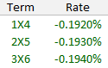
MLib doesn’t currently support IMM FRAs as used in for example SEK STIBOR. User however can work around this problem by pretending IMM FRAs were Futures and setting the Futures convexity adjustments to zero.
Each FRA instrument serves to produce the discount factors both at its start and end date. This is a quick two-step process:
- Obtain the start date discount factor from the DF interpolator object.
This discount factor is purely a result of interpolation based on discount factors obtained from calibration instruments prior to the FRAs;

- Calculate the end date discount factor by:

${DF}_{end}= {DF}_{start}* \frac{1}{1+ f_{FRA}* τ(T_{start}, { T}_{end})}$ (15)
MLib will subsequently inject both ${DF}_{end}$ and ${DF}_{start}$ back into the DF interpolator object to form the bootstrapping basis for the next instrument.

Futures
Futures are used to imply discount factors in almost the identical way as FRAs do in MLib. Futures however have their own unique features which are treated differently during the curve build:
- Forward rate $f_{Fut}$ is not directly given and backed out from the future prices $P_{fut}$

$f_{Fut}=1-P_{fut}/100$ (16)

- MLib supports convexity adjustment on $f_{Fut}$. This is because Futures do not have the same payoff as FRAs because of their daily marking to market mechanism.

Such an adjustment can either be provided directly as an input to the curve building function, or calculated internally by MLib through the forward rate volatility and mean reversion ratio (given as inputs) using Hull White one factor model;

- MLib supports both IMM Futures and Serial Futures;

Tension in FRAs/Futures
In order to combat undesired yield curve swings in the presence of rate hikes/drops around the FRAs/Futures area and to maintain a well-formed shape of the swap yield curve, MLib has introduced a technique to tactically introduce tension where the FRAs/Futures are used.
This technique works by inserting artificial ‘FRAs’ between existing FRA/Future instruments whose forward rates are created as a result of linear interpolation between forward rates of exiting FRA/Future.
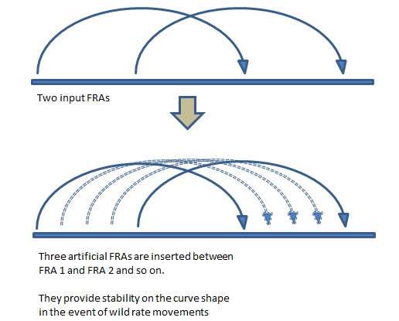

It is important to note that each artificial FRA is processed in exactly the same bootstrapping process as a normal FRA/Future does, producing discount factors on the instrument’s start date and end date.

Vanilla Interest Rate Swaps
Vanilla interest rate swaps are used to calibrate the rest of the swap curve following the FRA/Futures and MLib uses a solving approach here. Before we get into the details of the solving routine there are a few things to make note:
- A separate interpolator object is used to in the swap part of the yield curve. This awards the different sections of the swap yield curve the ability to interpolate under different schemes;

- The swap interpolator carries the logarithm of discount factors, or the product of zero rates and their corresponding tenors, $z\left(0,T\right)* τ(0,T)$, rather than either zero rates or discount factors. This interpolator is initialised with discount factors obtained prior to the swaps in the curve building process;
initialization
$$swap interpolator \overset{⇐}{ } -log⁡(All discount factors from Libor and FRAs/Futures)$$

Multi-variate Newton Raphson is used as the solving scheme so that all calibration swaps price to PV zero simultaneously. This is different from the OIS curve where each OIS swap is put through a independent NR routine one after another.
A multi-variate New Raphson enjoys the same formula as defined (5) except that all the variables are in the vector form:
$X_{n = }X_{n-1}-{\left(J_{f}\left(X_{n}\right)\right)}^{-1}F(X_{n-1})$ (17)
Where $X$ represents a vector of log DFs that that are individually mapped to the maturity tenor of each calibration swap and $F$ represents a vector of PV functions for the same group of swaps.
And the Jacobian is:
$J_{f }\left(X\right)= \left[\begin{matrix}\frac{∂f_{1}}{∂x_{1}} & ⋯ & \frac{∂f_{1}}{∂x_{n}} \\ ⋮ & ⋱ & ⋮ \\ \frac{∂f_{n}}{∂x_{1}} & ⋯ & \frac{∂f_{n}}{∂x_{n}}\end{matrix}\right]$ (18)

Where $f$ represent the PV function of a particular calibration swap and $x$ is the log DF that corresponds to a particular swap maturity tenor on the curve.
MLib sets up the swaps according to formulae (17) and (18) and then proceeds with the solving which will terminate once all the swaps price back to PV zero using the calibrated $X$:
${ PV}_{IRS}$
$=R\sum_{i=0}^{n-1}{τ_{fix}\left(t_{i,}, t_{i+1}\right) DF\left(0, t_{i+1}\right)-\sum_{i=0}^{m-1}{L\left(t_{i,}, t_{i+1}\right) τ_{float}\left(t_{i,}, t_{i+1}\right) DF\left(0, t_{i+1}\right)}}$ (19)
$$=0$$
Where
$L\left(t_{i,}, t_{i+1}\right)=\frac{\exp\left[z\left(0,i\right)τ\left(0,i\right)-z\left(0,i+1\right)τ\left(0,i+1\right)\right]-1}{τ\left(i, i+1\right)}$ (20)

The only unknown in formulae is $z$ and that’s our target.
Note:
In order to PV all the swaps MLib requires zero rates on non-pillar dates, i.e. the dates that do not coincide with calibration swap maturity tenors. MLib relies on the interpolator object to provide all the zero rates (in fact in this case the logarithm of discount factors) on non-pillar dates.

Tenor Basis Swaps
MLib allows tenor basis swaps to be used to help address some special cases in stripping the STD swap curve. One of the special cases is the AUD 3M curve.
In the AUD market interest rate swaps on 3M BBSW are quoted only up to 3Y. That makes it difficult to build the 3M AUD swap curve for longer tenors using 3M vanilla swap quotes only. To address this problem MLib builds the long end of the AUD 3M curve using 6M par swap quotes plus 3M-6M tenor basis spreads, in a similar way to how MLib uses Libor swap quotes plus Libor-OIS basis to complete the long end of OIS curve.

Tenor/Xccy Basis Curve
The third type of curve MLib supports is the basis curve and this can be either single currency tenor basis curve or cross currency basis curve. The latter is primarily used as CSA discounting curves.
Be it tenor basis or xccy basis, MLib basis curves use basis swap quotes as its primary calibration instruments. Similar to how the swap curve is calibrated using interest rate swaps, the basis curve is repeatedly adjusted at the whole-curve level in a multi-variate Newton Raphson solver to a point when all the calibration instruments price to par.
When stripping the xccy basis curve, MLib also accepts FX forward rate as one of the building blocks. This is particularly useful when short term xccy basis quotes are not liquid or don’t exist. Non-basis instruments such as FRAs are currently not supported at the time of writing but will be made available soon in MLib.

Spot Libor Instrument
Despite this being a basis curve which doesn’t yet accept no-basis instruments as inputs, if the curve being stripped is a Libor forecasting curve, MLib ensures the spot Libor interest rate of the corresponding tenor is one of the calibration instruments. For instance, when building a 6M basis curve MLib ensures that the 6M Libor rate is used to imply the discount factor at the 6M point of the curve using (14), exactly like how it’s done in the swap curve.
Note:
- The spot Libor instrument used by MLib’s basis curve is not set as an input to the basis curve; instead it’s set as a input to the swap curve as one of a group of spot interest rate deposit instruments.

- If the target basis curve is a discount curve, naturally all Libor instruments get ignored by MLib and won’t be used in the calibration process.

FX Forwards
When constructing a xccy basis curve, FX forwards are often used to build up the short end of the curve and used as useful complements to xccy basis swaps which then cover the rest of the curve. In a lot of markets xccy basis swap quotes are not granular enough for the short end. For instance, GBPUSD xccy basis quotes only cover 3M, 6M and 9M below one year and USDNOK are not even quoting anything below 1Y.
This drawback in the xccy basis swap market can be effectively compensated when MLib uses FX forwards which can be both liquid and granular and often support the following list of tenors with the ‘rate’ being forward quotation in pips:

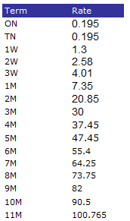
The basic principle of calibration using FX forwards is rather simple. Given the forward FX rate equation:
$$F(t, T)=S(t) \frac{{DF}_{foreign}(t,T)}{{DF}_{domestic}(t,T)}$$
MLib can easily deduce either ${DF}_{foreign}$ or ${DF}_{domestic}$ as long as the other discount factor is known. Both spot FX and forward FX rates are given as inputs.
Because FX spot rate is effectively the FX rate on the spot date, i.e. one or two days ahead of the as-of date, MLib relies on the ON and TN forward quotes to imply the discount factors between the as-of date and the spot date.
FX forwards are optional calibration instruments to MLib. When used, discount factors deduced from all the FX forwards will serve to instantiate a zero rate interpolator which will be later used in the basis swap solving routines.

Tenor Basis Swaps
Although a basis swap has a very similar product structure as a vanilla interest rate swap, the pricing complexity has gone up a notch thanks to the number of curves involved – typically three to four curves are involved; one forecast curve and one discount curve for one leg and the same with the other leg (In the case when both legs are sharing the same discount curve, only three curves are involved).
As a result, the key to successful calibration with basis swaps is that, when given two/three known curves as well as the quoted basis spreads, MLib needs to figure out what the only unknown curve should look like so that all the calibration swaps price to fair value?
A tenor basis swap set up in MLib is defined by the following equations:

${PV}_{Leg ref}= \sum_{i=0}^{m-1}{(f_{ref}\left(t_{i,}, t_{i+1}\right){+ R_{basis}) τ}_{ref}\left(t_{i,}, t_{i+1}\right) {DF}_{ref}\left(0, t_{i+1}\right)}$ (21)
${PV}_{Leg target}= \sum_{i=0}^{n-1}{f_{target}\left(t_{i,}, t_{i+1}\right) { τ}_{target}\left(t_{i,}, t_{i+1}\right) {DF}_{target}\left(0, t_{i+1}\right)}$ (22)
${ PV}_{Leg ref}= {PV}_{Leg target}$

The basis spread $R_{basis}$ is an input to MLib for each swap and can be configured to reside on either one of the two legs depending on the actual swap structure. Formula (21) is carrying $R_{basis}$ just for the purpose of illustration.
There is a reference leg in MLib’s basis swap set-up. The forecast curve and discount curve in this leg are always known and available to price the reference leg - in (21) both $f_{ref}$ and ${DF}_{ref}$ will be read off known curves.
Opposite the reference leg is the target leg and MLib will try to solve for either the forecast curve or discount curve of this leg – in (22) either $f_{target}$ or ${DF}_{target}$ is unknown.
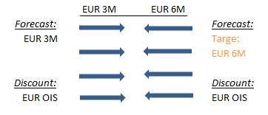
MLib user can determine through configuration whether the target curve is a forecast curve or discount curve. Also they are able to set exactly what are being solved for in the target curve:
- Logarithm of the target curve’s discount factors on pillar tenors, -$\log\left(DF\left(0, T\right)\right),$ or $z\left(0, T\right)τ\left(0, T\right).$
or
- Logarithm of spreads, -$\log\left(s\left(0, T\right)\right)$, which are to be added on top of the base curve in order to come to the target curve’s discount factors:

${DF}_{target}\left(0,T\right)=exp⁡[log⁡(s\left(0,T\right))+log⁡({DF}_{base}\left(0,T\right))]$ (23)

This is the recommended approach as the overall shape of the target curve can be more stable thanks to the existence of a base curve, whatever it is.
It’s worth mentioning that once the basis swaps have been properly set up for calibration, in search of the target variables MLib will go through a multi-variate Newton Raphson solving routine identical to that described in the swap curve section and by formulae (17) and (18). As a result this document won’t delve into the solving routine again for the basis curve.

Xccy Basis Swaps
Xccy basis swaps are used in the event of xccy basis curve calibration. Xccy basis spreads are specified as inputs to MLib’s basis curve function in exactly the same format as tenor basis spreads. When used, xccy basis swaps are used to calibrate the curve by going through the exact pieces of logics and routines to arrive at the target yield curve, the same as tenor basis swaps do.
However, there are specifics regarding xccy basis swaps that worth a further discussion.
Firstly, when pricing xccy basis swaps we need to consider notional exchanges at the front and back:
$${PV}_{Leg ref}$$
$= {-DF}_{ref}\left(0, T_{spot}\right)+\sum_{i=0}^{m-1}{(f_{ref}\left(t_{i,}, t_{i+1}\right){+ R_{basis})τ}_{ref}\left(t_{i,}, t_{i+1}\right){DF}_{ref}\left(0, t_{i+1}\right)}+ {DF}_{ref}\left(0, T\right)$ (23)
$${PV}_{Leg target}$$
$={-DF}_{target}\left(0, T_{spot}\right)+\sum_{i=0}^{n-1}{f_{target}\left(t_{i,}, t_{i+1}\right)τ_{target}\left(t_{i,}, t_{i+1}\right){DF}_{target}\left(0, t_{i+1}\right)+{DF}_{target}(0,T)}$ (24)
${ PV}_{Leg ref}= {PV}_{Leg target}$

Comparing (23) and (24) to (21) and (22) the main difference is the incorporation of discount factors on spot date and maturity date into the pricing formulae. In addition, the target curve in this case is typically the discount curve, i.e. ${DF}_{target}$ is the unknown variable. The rest of the calibration steps would be exactly the same as with tenor basis swaps.

It is important to stress that in reality however, MLib quite often doesn’t rely on (23) and (24) to PV xccy basis swaps in the calibration process. This is because in a lot of currencies, predominately G10 currencies, xccy basis spreads are quoted based on a Market-to-Market xccy swap structure which doesn’t quite follow (23) and (24). Notional adjustments now need to be considered on the USD leg in this type of swap.
When needed, MLib user can dictate (through the use of flag ‘IsRenotionalAdjust’) that the xccy basis curve is calibrated based on MTM xccy basis swaps so that the input basis spread quotes are accurately used in a correct product structure.
We use a EURUSD xccy basis swap as example to demonstrate how MLib deals with MTM xccy basis swaps.
In this example we have the EUR and USD forecast curve as well as the USD discount curve. The target is to solve for the EUR discount curve in USD CSA:
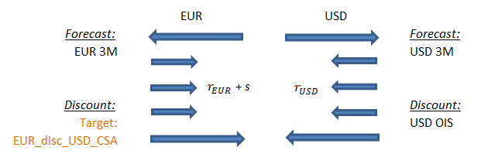
Given that EURUSD xccy basis swap quotes are based on MTM xccy swaps, the two legs are now priced like below:
(25)
(26)
Where $R$ is the quoted MTM xccy basis spread and notional of the two legs are related by:
(27)

Xccy Swaps
In addition to xccy basis swaps, MLib also supports xccy swap where one leg pays a fixed coupon and the other makes periodic payments linked to certain market index such as Libor.
An example case is when building a CNH discount curve in USD CSA. USDCNH swap has the CNH leg pay a fixed coupon and the quotation of this product is not the basis spread on the CNH leg. Instead the quotation is the CNH leg’s fixed coupon rate, similar to par rate of vanilla interest rate swaps.
Again, xccy swaps are fed through the same solving routines and logics as tenor/xccy basis swaps do to arrive at the calibration results.

FX Forward Constant Curve
FX forward constant curve in MLib is more or less specifically used to create non-USD CSA discounting curve. In the previous section it has already been discussed that by building an xccy basis curve, MLib can create non-USD discounting curve in USD CSA using USDXXX xccy basis swaps. The FX forward constant curve can go one step further and allows user to create non-USD discounting curve in non-USD CSA through this principle: Discount curves of two currencies should yield a constant FX forward rate of a particular maturity tenor, regardless of the collateral currency embedded in the two discount curves.
Take EURGBP for example.
If a MLib user has built a EUR OIS curve and GBP OIS curve (using the OIS curve building function), the following relationship stands:
$F_{EURGBP}\left(t, T\right)=S\left(t\right)*\frac{{DF}_{EUR_OIS}(t, T)}{{DF}_{GBP_OIS}(t, T)}$ (28)
If a user has created a EUR discount curve in USD CSA and a GBP discount curve in USD CSA (using the xccy basis curve building function), the following relationship should stand:
$F_{EURGBP}\left(t, T\right)=S\left(t\right)*\frac{{DF}_{EUR_USD_CSA}(t, T)}{{DF}_{GBP_USD_CSA}(t, T)}$ (29)
Based on the principle demonstrated by (28) and (29), it becomes obvious the following also holds:
$$F_{EURGBP}\left(t, T\right)=S\left(t\right)*\frac{{DF}_{EUR_EUR_CSA}(t, T)}{{DF}_{GBP_EUR_CSA}(t, T)}$$
$=S\left(t\right)*\frac{{DF}_{EUR_OIS}(t, T)}{{DF}_{GBP_EUR_CSA}(t, T)}$ (30)
Where a EUR curve in EUR CSA is simply the standard EUR OIS curve.
Linking (29) and (30) together via the constant FX forward rates, it’s apparent that a GBP curve in EUR CSA can be derived through a EUR OIS curve, a GBP curve in USD CSA (basis curve) and a EUR curve in USD CSA (basis curve):
${DF}_{GBP_EUR_CSA}\left(t, T\right)= {DF}_{EUR_OIS}\left(t, T\right)*\frac{{DF}_{GBP_USD_CSA}(t, T)}{{DF}_{EUR_USD_CSA}(t, T)}$ (31)
And (31) is essentially the principle MLib logics are based on in order to derive discounting curve in non-USD CSA.

Appendix 1: Yield Curve State Variables
Using the below definition of the discount factor (DF), where z denotes the corresponding zero rate and t < T,
$DF\left(t, T\right)= exp⁡(-z*\left(T-t\right))$ (32)
yield curves are calibrated and interpolated with respect to the following state variables

Table 1: Yield Curve State Variables
Curve Type Instruments State Variable
OIS Curve All Zero Rates
Swap Curve Futures / FRAs Log of Discount Factors
Swap Curve Swap Log of Discount Factors
Tenor & Xccy Basis Curves FX Forwards Discount Factors
Tenor & Xccy Basis Curves Basis Swaps Log of Discount Factors
FX Forward Constant Curve N/A Implied from Dependency Curves
Cheapest-to-Deliver Curve N/A Implied from Dependency Curves

Appendix 2: Yield Curve Key Parameter Settings
We highlight key parameter settings used in yield curve construction for the OIS, STD Swap, Tenor Basis, Xccy Basis curves respectively.

2A: OIS Curve Settings
CompoundingMethod ARITHMETIC, GEOMETRIC, SIMPLE, FLAT
This parameter specifies the OIS coupon compounding methodology, which includes arithmetic averaging, geometric averaging, simple and flat.

LongTerm.GenerateMethod LOBASIS
This field is used to specify if Libor-OIS spread instruments are to be specified and included as calibration instruments. Simply enter LOBASIS to include and leave blank to not use Libor-OIS spread instruments.
LongTermConvention Example: 3Y
Here we specify a tenor representing the join point for outright OIS and Libor-OIS basis calibration instruments. For example a 3Y tenor would imply that we use outright OIS swaps up to and excluding the 3 year point and Libor-OIS spread instruments from and including the 3 year quotes.
SmoothShortEnd TRUE, FALSE
When using central bank swaps such as ECB swaps or Fed Futures instruments in the outright section we must specify whether we wish to include any short dated OIS swaps that are quoted before central bank swaps such as O/N, T/N, 1W etc. TRUE indicates we wish to include short dated OIS swaps and FALSE excludes them.

2B: STD Swap Curve Settings
AlwaysCalcJoinDate TRUE, FALSE
The Swap curve has a dynamic futures / swap join date when using a hybrid interpolation method such as Linear-Spline interpolation. During calibration a join date is selected to provide the smoothest curve shape over the join as possible. This works well when using curves for pricing, however numerical risk calculations are more stable if we use a fixed join date. This flag allows the end user to control the join date calculation, when TRUE a join date is always dynamically calculated and we optimize for the smoothest curve shape. When set to FALSE we re-use the join date for stable numerical risk calculations. The default value is TRUE.

ApplyTension TRUE, FALSE
When set to TRUE this flag, which is specified within the Futures and FRAs convention blocks, will insert synthetic points to replicate linear interpolation and thereby simulate curve tension. Note the ‘TensionGap’ parameter needs to be set in conjunction with this parameter to control the number of synthetic points used.
GenerateForwardsFromSwapsOnly TRUE / FALSE
Specified within the curve build properties, this parameter manages the calibration of Libor forward rates when futures and swap calibration dates conflict. In the event of a date conflict between futures and swap dates TRUE prioritizes the swaps and FALSE the futures. The default value is TRUE i.e. swaps take priority.
IsTenorAdjust TRUE / FALSE
This flag is used to indicate whether a swap curve includes swap instruments with mixed Libor frequencies are being used simultaneously. For example in AUD curves swaps less than and including the 3 year swap quote with a quarterly floating frequency with AUD3ML as the Libor index and thereafter are semi-annual using AUD6ML.
When set to TRUE mixed Libor swaps are enabled and the swap curve requires tenor basis swap conventions and market data to consolidate and convert the calibration inputs to a single tenor homogenous curve.
LinearSplineJoinDate A Date
An optional field used to specify and override the join date used when using Linear-Spline interpolation. This allows the end user to fully specify which part of the curve should be Linear interpolated and which part should use Spline interpolation. Forward rates are linear before the join date and spline afterwards.
MeanReversion Example: 0%, 1%, 2%
Used within the futures conventions, we enter a number in percent to control futures convexity adjustments. This parameter specifies the mean reversion to be used in the Hull-White 1 factor model. A value of 0% is equivalent to applying the Ho-Lee convexity adjustments.

OptimizePerformance TRUE, FALSE
Controls the Newton-Raphson calibration precision and exit criteria. Used within the swaps conventions section, TRUE optimizes for performance and exits the solver once a single instrument calibrates within precision tolerance, which is acceptable with high precision settings. FALSE ensures that all instruments calibrate within tolerance. The default value is FALSE.

TensionGap Example: 1, 2, 3 … Days
This flag is set in conjunction with the ‘ApplyTension’ flag and controls the frequency in days of how often to insert artificial linear points to the futures or FRAs section of the swap curve. Empirically we find that a tension gap of 2 days works best.

UseConvexAdjustment TRUE, FALSE
This parameter is used in the futures conventions table to allow users to override the model derived Eurodollar futures adjustments and specify absolute convexity adjustments instead. When TRUE we must specify absolute convexity adjustments in the futures data block and when FALSE is specified we must specify Hull-White volatilities, see figure 1 below.

Figure 1: Futures Calibration Data Input
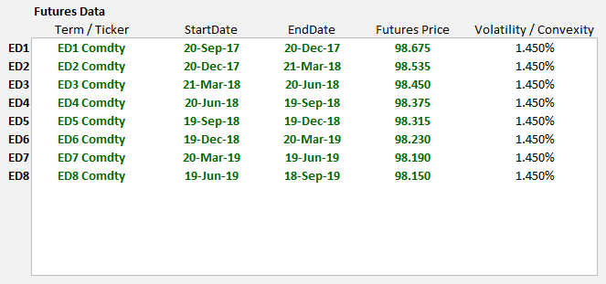

2C: Tenor- & Xccy Basis Curve Settings

isFwdBasis TRUE, FALSE
Specified as part of the curve build properties, this flag controls if Tenor Basis instruments are forward starting. When set to TRUE we must include three additional columns of data within the tenor basis spread table to specify: i) isDateFormat (Boolean) ii) the start date or tenor iii) the end date or tenor for each basis quote as shown in figure 2 below.
Figure 2: Tenor Basis Spread Calibration Data Input
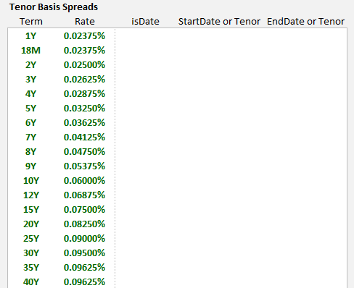
isFwdInter TRUE, FALSE
This parameter is specified within the basis conventions and is used for both Tenor and Xccy Basis curves. Post calibration STD Swap curves store a table of discount factor and forward rate results. Setting this parameter to TRUE interpolates swap curves by forwards using equation (36) below and FALSE will interpolate by discount factors using equation (33).
Within basis curves this flag can only be set to true when the dependency curve is a swap curve. An error will be returned if this flag is set to true and the dependency curve is a basis curve. We should also specify the interpolation method when setting isFwdInter = TRUE using the ‘fwdInterpolation’ flag. The choice of fwdInterpolation must match the interpolation method set in the swap curve for calibration consistency.
We recommend building swap curves using Linear-Spline interpolation and specifying basis curves with isFwdInter set to TRUE and fwdInterpolation set to use Linear-Spline interpolation.
On calibration node points both the Libor forward rate and discount factor tables are synchronized. We summarize these calculations below and highlight that interpolated points can have different values and can cause pricing differences.
The forward / discount factor relationship is summarized mathematically as
$DF\left(t,T\right)≝\frac{1}{1+f*(T-t)}$ (33)
we also know that
$DF\left(t,S\right)*DF\left(S,T\right)=DF\left(t,T\right)$ (34)
combining the above gives
$\frac{1}{1+f*(T-S)}= DF\left(S,T\right)=\frac{DF(t,S)}{DF(t,T)}$ (35)
leading to
$f=\left(\frac{DF(t,T)}{DF(t,S)}-1\right)*\left(\frac{1}{(T-S)}\right)$ (36)
where t<S<T

FixingSource CurveCollection name or ‘ITSELF’ keyword
The fixing source parameter is part of the basis curve build properties. Traditionally all cash fixings are specified as part of the STD swap curve. A fixing table will only be sourced from swap curves when the market id or static data table name set using the ‘STD’ keyword. Furthermore basis curves only calibrate using a cash Libor fixing if the ‘SpotRateTerm’ field is specified, see below.
Additionally basis curves can specify their own Libor fixings if the FixingSource parameter is set using the ITSELF keyword. The fixing source can also point to a STD swap curve in a different curve collection, which is quite useful for curves such as JPY TIBOR where the basis is a spread to JSCC LIBOR but the fixings need to come from a JPY TIBOR curve.

OptimizePerformance TRUE, FALSE
Controls the Newton-Raphson calibration precision and exit criteria. Used within the swaps conventions section, TRUE optimizes for performance and exits the solver once a single instrument calibrates within precision tolerance, which is acceptable with high precision tolerance. FALSE ensures that all instruments calibrate within tolerance. The default value is FALSE.

SpotRateTerm 1M, 3M, 6M, 12M
This parameter is set within the tenor basis conventions input block and specifies which fixing to use from the STD swap curve fixing table. The swap curve containing the fixing data must specify and the STD keyword as its MarketID or StaticDataTable name. Omitting this field will result in no cash Libor fixing being used in basis curve calibration.

2D: FX Forward Curve Settings
The FX Forward curve solves for any CSA discount curve using a combination of standard OIS and Xccy curves. MLIB implies the collateralized discount curve using the FX Forward invariance relationship such as that in (37) solving for the one unknown term.
For example to solve for a discount curve, such as GBP_EURCSA i.e. a GBP discount factor adjusted for EUR collateral posting, we have the following FX Forward relationship
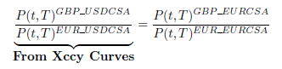 (37)
re-arranging this gives 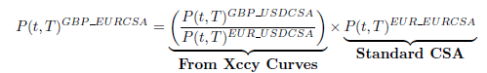 (38)
In MLIB we represent (37) as
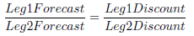 (39)
and likewise (38) is represented as
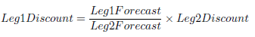 (40)

In MLIB we set-up the FX Forward Curve to represent equation (40) as shown in table 2.
Table 2: FX Forward Constant Settings for GBP_EURCSA
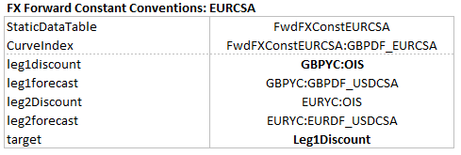
However it is perhaps easier to consider the settings in table 2 as a representation of equation (39), where the target parameter specifies what we are solving for. In this case we solve for the Leg1 discount factor i.e. GBPDF_EURCSA and therefore the leg1 discount term specified i.e. GBPYC:OIS is treated as the initial guess for the analytics solver.
Please note that if we invert equation (39) we achieve the same results, since this mathematically equivalent.

or log of spreads added on top of the base curve
Note that inverting this expression yields the same result.

